WISC-V Composition

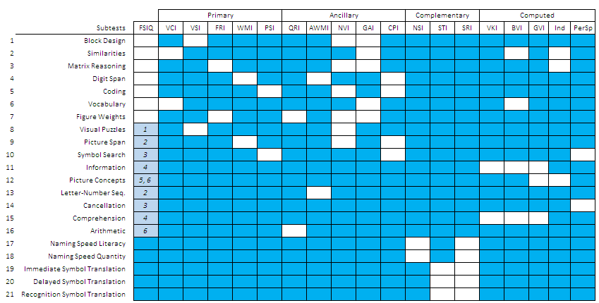

Gf-Gc Classification and WISC-V Subtests
Gc - Comprehension/Knowledge
Similarities (Language Development)
Comprehension (Language Development)
Information (General (Verbal) Information)
Vocabulary (Lexical Knowledge)
Gv - Visual Spatial
Block Design (Spatial Relations)
Visual Puzzles (Spatial Relations, Visualization)
Gsm - Short term Memory
Digit Span (Memory Span)
Digit Span Forward (Memory Span)
Digit Span Backward (Working Memory)
Digit Span Sequencing(Working Memory)
Letter-Number Sequencing (Working Memory)
Picture Span (Working Memory)
Gs - Processing Speed
Symbol Search (Perceptual Speed)
Cancellation (Perceptual Speed)
Coding (Rate-of-Test-Taking)
Naming Speed Literacy (Speed of Lexical Access)*
Naming Speed Quantity (Speed of Lexical Access)*
Glr - Long term Storage
Immediate Symbol Translation (Associative Memory)*
Delayed Symbol Translation (Associative Memory)*
Recognition Symbol translation (Associative Memory)*
Gf - Fluid Reasoning
Matrix Reasoning (Inductive Reasoning)
Figure Weights (Quantitative Reasoning)
Picture Concepts (Inductive Reasoning, General (Verbal) Information)
Gq - Quantitative
Arithmetic (Math Achievement, Working memory, Fluid Reasoning)
* The WISC-V does not consider these subtests as measures of intelligence

Note: Ga – Auditory Processing is not measure specifically by any WISC-V subtest

